HomeWork1
Họ và tên: Phạm Thế Đạt
MSSV: 20235676

- HelloWorld
- Code:
HelloWorld.class:
import java.awt.Component;
import javax.swing.JOptionPane;
public class HelloWorld {
public HelloWorld() {
}
public static void main(String[] var0) {
String var1 = JOptionPane.showInputDialog("Hay nhap ten cua ban:");
JOptionPane.showMessageDialog((Component)null, "Hello " + var1);
}
}
HelloWorld.java:
import javax.swing.*;

public class HelloWorld {
public static void main(String[] args) {
String name = JOptionPane.showInputDialog("Hay nhap ten cua ban:");
JOptionPane.showMessageDialog(null, "Hello " + name );
}
}

- Kết quả
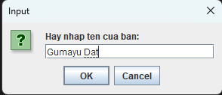
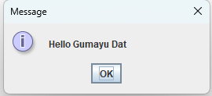

- Calculator sử dụng Swing
- Code
Calculator Controller:
package MVCSwing;

import java.awt.event.ActionEvent;
import java.awt.event.ActionListener;

public class CalculatorController {

private CalculatorView theView;
private CalculatorModel theModel;

public CalculatorController(CalculatorView theView, CalculatorModel theModel) {
this.theView = theView;
this.theModel = theModel;

this.theView.addCalculateListener(new CalculateListener());
}

class CalculateListener implements ActionListener{

public void actionPerformed(ActionEvent e) {

int firstNumber, secondNumber = 0;

try{

firstNumber = theView.getFirstNumber();
secondNumber = theView.getSecondNumber();

theModel.addTwoNumbers(firstNumber, secondNumber);

theView.setCalcSolution(theModel.getCalculationValue());

}

catch(NumberFormatException ex){

System.out.println(ex);

theView.displayErrorMessage("You Need to Enter 2 Integers");

}

}

}

}
Calculator Model:
package MVCSwing;

public class CalculatorModel {

private int calculationValue;

public void addTwoNumbers(int firstNumber, int secondNumber){

calculationValue = firstNumber + secondNumber;

}

public int getCalculationValue(){

return calculationValue;

}

}

MVCCalculator:
package MVCSwing;

public class MVCCalculator {

public static void main(String[] args) {

CalculatorView theView = new CalculatorView();

CalculatorModel theModel = new CalculatorModel();

CalculatorController theController = new CalculatorController(theView,theModel);

theView.setVisible(true);

}
}

CalculatorView:
package MVCSwing;

import java.awt.event.ActionListener;

import javax.swing.*;

public class CalculatorView extends JFrame{

private JTextField firstNumber = new JTextField(10);
private JLabel additionLabel = new JLabel("+");
private JTextField secondNumber = new JTextField(10);
private JButton calculateButton = new JButton("Calculate");
private JTextField calcSolution = new JTextField(10);

CalculatorView(){

JPanel calcPanel = new JPanel();

this.setDefaultCloseOperation(JFrame.EXIT_ON_CLOSE);
this.setSize(600, 200);

calcPanel.add(firstNumber);
calcPanel.add(additionLabel);
calcPanel.add(secondNumber);
calcPanel.add(calculateButton);
calcPanel.add(calcSolution);

this.add(calcPanel);

}

public int getFirstNumber(){

return Integer.parseInt(firstNumber.getText());

}

public int getSecondNumber(){

return Integer.parseInt(secondNumber.getText());

}

public int getCalcSolution(){

return Integer.parseInt(calcSolution.getText());

}

public void setCalcSolution(int solution){

calcSolution.setText(Integer.toString(solution));

}

void addCalculateListener(ActionListener listenForCalcButton){

calculateButton.addActionListener(listenForCalcButton);

}

void displayErrorMessage(String errorMessage){

JOptionPane.showMessageDialog(this, errorMessage);

}

}

- Kết quả
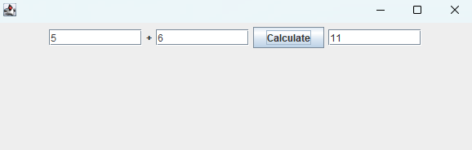
- Calculator sử dụng Fx
- Code:
CaculatorControllerFx.class:
package MVCJavaFx;

import javafx.scene.control.Alert;
import javafx.scene.control.Alert.AlertType;

public class CalculatorControllerFx {
private CalculatorViewFx view;
private CalculatorModelFx model;

public CalculatorControllerFx(CalculatorViewFx var1, CalculatorModelFx var2) {
this.view = var1;
this.model = var2;
this.initializeHandlers();
}

private void initializeHandlers() {
this.view.getAddButton().setOnAction((var1) -> this.handleAdd());
this.view.getSubtractButton().setOnAction((var1) -> this.handleSubtract());
this.view.getMultiplyButton().setOnAction((var1) -> this.handleMultiply());
this.view.getDivideButton().setOnAction((var1) -> this.handleDivide());
this.view.getClearButton().setOnAction((var1) -> this.handleClear());
}

private void handleAdd() {
try {
double var1 = Double.parseDouble(this.view.getFirstNumberField().getText());
double var3 = Double.parseDouble(this.view.getSecondNumberField().getText());
double var5 = this.model.add(var1, var3);
this.view.getResultField().setText(String.valueOf(var5));
} catch (NumberFormatException var7) {
this.showError("Vui lòng nhập số hợp lệ!");
}

}

private void handleSubtract() {
try {
double var1 = Double.parseDouble(this.view.getFirstNumberField().getText());
double var3 = Double.parseDouble(this.view.getSecondNumberField().getText());
double var5 = this.model.subtract(var1, var3);
this.view.getResultField().setText(String.valueOf(var5));
} catch (NumberFormatException var7) {
this.showError("Vui lòng nhập số hợp lệ!");
}

}

private void handleMultiply() {
try {
double var1 = Double.parseDouble(this.view.getFirstNumberField().getText());
double var3 = Double.parseDouble(this.view.getSecondNumberField().getText());
double var5 = this.model.multiply(var1, var3);
this.view.getResultField().setText(String.valueOf(var5));
} catch (NumberFormatException var7) {
this.showError("Vui lòng nhập số hợp lệ!");
}

}

private void handleDivide() {
try {
double var1 = Double.parseDouble(this.view.getFirstNumberField().getText());
double var3 = Double.parseDouble(this.view.getSecondNumberField().getText());
double var5 = this.model.divide(var1, var3);
this.view.getResultField().setText(String.valueOf(var5));
} catch (NumberFormatException var7) {
this.showError("Vui lòng nhập số hợp lệ!");
} catch (ArithmeticException var8) {
this.showError(var8.getMessage());
}

}

private void handleClear() {
this.view.getFirstNumberField().clear();
this.view.getSecondNumberField().clear();
this.view.getResultField().clear();
}

private void showError(String var1) {
Alert var2 = new Alert(AlertType.ERROR);
var2.setTitle("Lỗi");
var2.setHeaderText((String)null);
var2.setContentText(var1);
var2.showAndWait();
}
}
CaculatorControllerFx.java:
package MVCJavaFx;

import javafx.scene.control.Alert;
import javafx.scene.control.Alert.AlertType;

public class CalculatorControllerFx {

private CalculatorViewFx view;
private CalculatorModelFx model;

public CalculatorControllerFx(CalculatorViewFx view, CalculatorModelFx model) {
this.view = view;
this.model = model;

// Gắn sự kiện cho các nút
initializeHandlers();
}

private void initializeHandlers() {
// Sự kiện nút cộng
view.getAddButton().setOnAction(e -> handleAdd());

// Sự kiện nút trừ
view.getSubtractButton().setOnAction(e -> handleSubtract());

// Sự kiện nút nhân
view.getMultiplyButton().setOnAction(e -> handleMultiply());

// Sự kiện nút chia
view.getDivideButton().setOnAction(e -> handleDivide());

// Sự kiện nút xóa
view.getClearButton().setOnAction(e -> handleClear());
}

private void handleAdd() {
try {
double num1 = Double.parseDouble(view.getFirstNumberField().getText());
double num2 = Double.parseDouble(view.getSecondNumberField().getText());
double result = model.add(num1, num2);
view.getResultField().setText(String.valueOf(result));
} catch (NumberFormatException e) {
showError("Vui lòng nhập số hợp lệ!");
}
}

private void handleSubtract() {
try {
double num1 = Double.parseDouble(view.getFirstNumberField().getText());
double num2 = Double.parseDouble(view.getSecondNumberField().getText());
double result = model.subtract(num1, num2);
view.getResultField().setText(String.valueOf(result));
} catch (NumberFormatException e) {
showError("Vui lòng nhập số hợp lệ!");
}
}

private void handleMultiply() {
try {
double num1 = Double.parseDouble(view.getFirstNumberField().getText());
double num2 = Double.parseDouble(view.getSecondNumberField().getText());
double result = model.multiply(num1, num2);
view.getResultField().setText(String.valueOf(result));
} catch (NumberFormatException e) {
showError("Vui lòng nhập số hợp lệ!");
}
}

private void handleDivide() {
try {
double num1 = Double.parseDouble(view.getFirstNumberField().getText());
double num2 = Double.parseDouble(view.getSecondNumberField().getText());
double result = model.divide(num1, num2);
view.getResultField().setText(String.valueOf(result));
} catch (NumberFormatException e) {
showError("Vui lòng nhập số hợp lệ!");
} catch (ArithmeticException e) {
showError(e.getMessage());
}
}

private void handleClear() {
view.getFirstNumberField().clear();
view.getSecondNumberField().clear();
view.getResultField().clear();
}

private void showError(String message) {
Alert alert = new Alert(AlertType.ERROR);
alert.setTitle("Lỗi");
alert.setHeaderText(null);
alert.setContentText(message);
alert.showAndWait();
}
}
CaculatorModelFx.class:
package MVCJavaFx;

public class CalculatorModelFx {
private double result;

public CalculatorModelFx() {
}

public double add(double var1, double var3) {
this.result = var1 + var3;
return this.result;
}

public double subtract(double var1, double var3) {
this.result = var1 - var3;
return this.result;
}

public double multiply(double var1, double var3) {
this.result = var1 * var3;
return this.result;
}

public double divide(double var1, double var3) throws ArithmeticException {
if (var3 == (double)0.0F) {
throw new ArithmeticException("Không thể chia cho 0");
} else {
this.result = var1 / var3;
return this.result;
}
}

public double getResult() {
return this.result;
}
}
CaculatorModelFx.java:
package MVCJavaFx;
public class CalculatorModelFx {
private double result;
// Phép cộng
public double add(double num1, double num2) {
result = num1 + num2;
return result;
}
// Phép trừ
public double subtract(double num1, double num2) {
result = num1 - num2;
return result;
}

// Phép nhân
public double multiply(double num1, double num2) {
result = num1 * num2;
return result;
}
// Phép chia
public double divide(double num1, double num2) throws ArithmeticException {
if (num2 == 0) {
throw new ArithmeticException("Không thể chia cho 0");
}
result = num1 / num2;
return result;
}

public double getResult() {
return result;
}
}
CaculatorViewFx.class:
package MVCJavaFx;

import javafx.geometry.Insets;
import javafx.geometry.Pos;
import javafx.scene.Node;
import javafx.scene.Scene;
import javafx.scene.control.Button;
import javafx.scene.control.Label;
import javafx.scene.control.TextField;
import javafx.scene.layout.GridPane;
import javafx.scene.layout.HBox;
import javafx.scene.layout.VBox;
import javafx.stage.Stage;

public class CalculatorViewFx {
private Stage stage;
private TextField firstNumberField;
private TextField secondNumberField;
private TextField resultField;
private Button addButton;
private Button subtractButton;
private Button multiplyButton;
private Button divideButton;
private Button clearButton;

public CalculatorViewFx(Stage var1) {
this.stage = var1;
this.initialize();
}

private void initialize() {
Label var1 = new Label("Máy Tính Đơn Giản");
var1.setStyle("-fx-font-size: 20px; -fx-font-weight: bold;");
GridPane var2 = new GridPane();
var2.setHgap((double)10.0F);
var2.setVgap((double)10.0F);
var2.setAlignment(Pos.CENTER);
Label var3 = new Label("Số thứ nhất:");
this.firstNumberField = new TextField();
this.firstNumberField.setPromptText("Nhập số thứ nhất");
this.firstNumberField.setPrefWidth((double)200.0F);
Label var4 = new Label("Số thứ hai:");
this.secondNumberField = new TextField();
this.secondNumberField.setPromptText("Nhập số thứ hai");
this.secondNumberField.setPrefWidth((double)200.0F);
var2.add(var3, 0, 0);
var2.add(this.firstNumberField, 1, 0);
var2.add(var4, 0, 1);
var2.add(this.secondNumberField, 1, 1);
HBox var5 = new HBox((double)10.0F);
var5.setAlignment(Pos.CENTER);
this.addButton = new Button("+");
this.subtractButton = new Button("-");
this.multiplyButton = new Button("×");
this.divideButton = new Button("÷");
this.addButton.setPrefWidth((double)60.0F);
this.subtractButton.setPrefWidth((double)60.0F);
this.multiplyButton.setPrefWidth((double)60.0F);
this.divideButton.setPrefWidth((double)60.0F);
this.addButton.setStyle("-fx-font-size: 16px;");
this.subtractButton.setStyle("-fx-font-size: 16px;");
this.multiplyButton.setStyle("-fx-font-size: 16px;");
this.divideButton.setStyle("-fx-font-size: 16px;");
var5.getChildren().addAll(new Node[]{this.addButton, this.subtractButton, this.multiplyButton, this.divideButton});
HBox var6 = new HBox((double)10.0F);
var6.setAlignment(Pos.CENTER);
Label var7 = new Label("Kết quả:");
var7.setStyle("-fx-font-weight: bold;");
this.resultField = new TextField();
this.resultField.setEditable(false);
this.resultField.setPrefWidth((double)200.0F);
this.resultField.setStyle("-fx-background-color: #f0f0f0;");
var6.getChildren().addAll(new Node[]{var7, this.resultField});
this.clearButton = new Button("Xóa");
this.clearButton.setPrefWidth((double)100.0F);
VBox var8 = new VBox((double)15.0F);
var8.setAlignment(Pos.CENTER);
var8.setPadding(new Insets((double)20.0F));
var8.getChildren().addAll(new Node[]{var1, var2, var5, var6, this.clearButton});
Scene var9 = new Scene(var8, (double)400.0F, (double)300.0F);
this.stage.setTitle("Máy Tính MVC JavaFX");
this.stage.setScene(var9);
this.stage.setResizable(false);
}

public TextField getFirstNumberField() {
return this.firstNumberField;
}

public TextField getSecondNumberField() {
return this.secondNumberField;
}

public TextField getResultField() {
return this.resultField;
}

public Button getAddButton() {
return this.addButton;
}

public Button getSubtractButton() {
return this.subtractButton;
}

public Button getMultiplyButton() {
return this.multiplyButton;
}

public Button getDivideButton() {
return this.divideButton;
}

public Button getClearButton() {
return this.clearButton;
}

public void show() {
this.stage.show();
}
}
CaculatorViewFx.Java:
package MVCJavaFx;

import javafx.geometry.Insets;
import javafx.geometry.Pos;
import javafx.scene.Scene;
import javafx.scene.control.Button;
import javafx.scene.control.Label;
import javafx.scene.control.TextField;
import javafx.scene.layout.GridPane;
import javafx.scene.layout.HBox;
import javafx.scene.layout.VBox;
import javafx.stage.Stage;

public class CalculatorViewFx {

private Stage stage;
private TextField firstNumberField;
private TextField secondNumberField;
private TextField resultField;
private Button addButton;
private Button subtractButton;
private Button multiplyButton;
private Button divideButton;
private Button clearButton;

public CalculatorViewFx(Stage stage) {
this.stage = stage;
initialize();
}

private void initialize() {
// Tạo các thành phần giao diện
Label titleLabel = new Label("Máy Tính Đơn Giản");
titleLabel.setStyle("-fx-font-size: 20px; -fx-font-weight: bold;");

// GridPane cho các trường nhập liệu
GridPane inputGrid = new GridPane();
inputGrid.setHgap(10);
inputGrid.setVgap(10);
inputGrid.setAlignment(Pos.CENTER);

Label label1 = new Label("Số thứ nhất:");
firstNumberField = new TextField();
firstNumberField.setPromptText("Nhập số thứ nhất");
firstNumberField.setPrefWidth(200);

Label label2 = new Label("Số thứ hai:");
secondNumberField = new TextField();
secondNumberField.setPromptText("Nhập số thứ hai");
secondNumberField.setPrefWidth(200);

inputGrid.add(label1, 0, 0);
inputGrid.add(firstNumberField, 1, 0);
inputGrid.add(label2, 0, 1);
inputGrid.add(secondNumberField, 1, 1);

// HBox cho các nút phép tính
HBox buttonBox = new HBox(10);
buttonBox.setAlignment(Pos.CENTER);

addButton = new Button("+");
subtractButton = new Button("-");
multiplyButton = new Button("×");
divideButton = new Button("÷");

addButton.setPrefWidth(60);
subtractButton.setPrefWidth(60);
multiplyButton.setPrefWidth(60);
divideButton.setPrefWidth(60);

addButton.setStyle("-fx-font-size: 16px;");
subtractButton.setStyle("-fx-font-size: 16px;");
multiplyButton.setStyle("-fx-font-size: 16px;");
divideButton.setStyle("-fx-font-size: 16px;");

buttonBox.getChildren().addAll(addButton, subtractButton, multiplyButton, divideButton);

// HBox cho kết quả
HBox resultBox = new HBox(10);
resultBox.setAlignment(Pos.CENTER);

Label resultLabel = new Label("Kết quả:");
resultLabel.setStyle("-fx-font-weight: bold;");

resultField = new TextField();
resultField.setEditable(false);
resultField.setPrefWidth(200);
resultField.setStyle("-fx-background-color: #f0f0f0;");

resultBox.getChildren().addAll(resultLabel, resultField);

// Nút xóa
clearButton = new Button("Xóa");
clearButton.setPrefWidth(100);

// VBox chứa tất cả
VBox root = new VBox(15);
root.setAlignment(Pos.CENTER);
root.setPadding(new Insets(20));
root.getChildren().addAll(titleLabel, inputGrid, buttonBox, resultBox, clearButton);

// Tạo Scene và thiết lập Stage
Scene scene = new Scene(root, 400, 300);
stage.setTitle("Máy Tính MVC JavaFX");
stage.setScene(scene);
stage.setResizable(false);
}

// Getter methods
public TextField getFirstNumberField() {
return firstNumberField;
}

public TextField getSecondNumberField() {
return secondNumberField;
}

public TextField getResultField() {
return resultField;
}

public Button getAddButton() {
return addButton;
}

public Button getSubtractButton() {
return subtractButton;
}

public Button getMultiplyButton() {
return multiplyButton;
}

public Button getDivideButton() {
return divideButton;
}

public Button getClearButton() {
return clearButton;
}

public void show() {
stage.show();
}
}
MVCJavaFx.class:
package MVCJavaFx;

import javafx.application.Application;
import javafx.stage.Stage;

public class MVCJavaFX extends Application {
public MVCJavaFX() {
}

public void start(Stage var1) {
try {
CalculatorModelFx var2 = new CalculatorModelFx();
CalculatorViewFx var3 = new CalculatorViewFx(var1);
new CalculatorControllerFx(var3, var2);
var3.show();
} catch (Exception var5) {
var5.printStackTrace();
}

}

public static void main(String[] var0) {
launch(var0);
}
}
MVCJavaFx.java:
package MVCJavaFx;
import javafx.application.Application;
import javafx.stage.Stage;
public class MVCJavaFX extends Application {
@Override
public void start(Stage primaryStage) {
try {
// Tạo Model
CalculatorModelFx model = new CalculatorModelFx();

// Tạo View
CalculatorViewFx view = new CalculatorViewFx(primaryStage);

// Tạo Controller và kết nối View với Model
CalculatorControllerFx controller = new CalculatorControllerFx(view, model);

// Hiển thị giao diện
view.show();

} catch (Exception e) {
e.printStackTrace();
}
}

public static void main(String[] args) {
launch(args);
}
}
- Kết quả
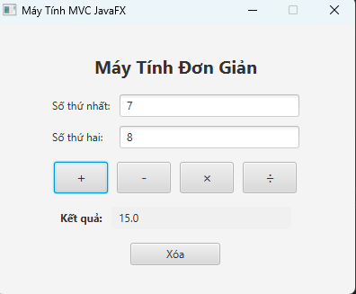
- GIT
- Add
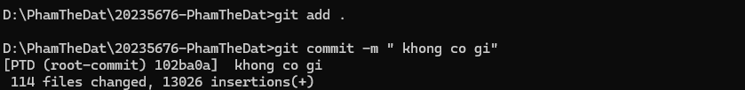
- Remove
- Modify
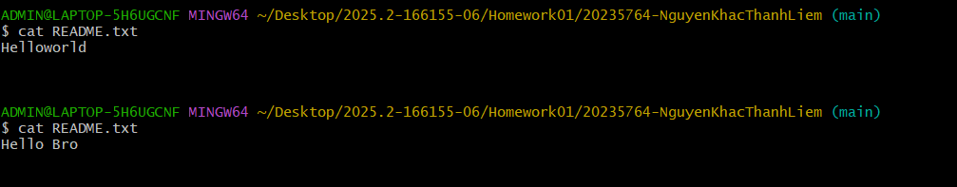
- Commit
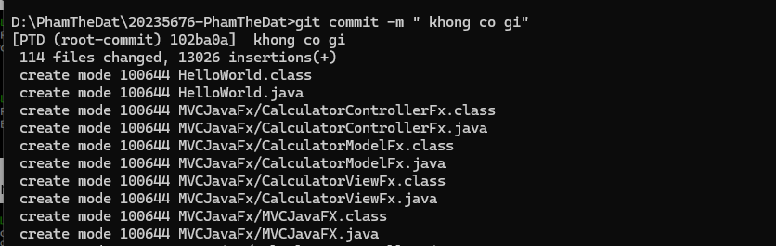
- Push
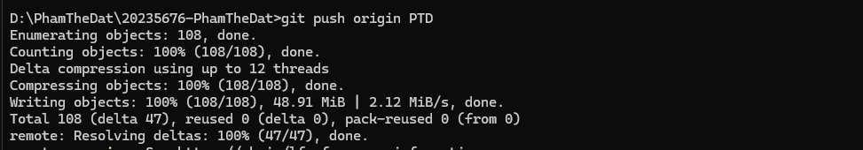
- Pull
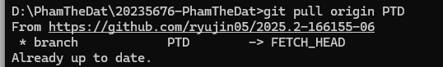
- Merge
